
МИНИСТЕРСТВО НАУКИ И ВЫСШЕГО ОБРАЗОВАНИЯ РОССИЙСКОЙ ФЕДЕРАЦИИ
федеральное государственное бюджетное образовательное учреждение высшего образования
«УЛЬЯНОВСКИЙ ГОСУДАРСТВЕННЫЙ ТЕХНИЧЕСКИЙ УНИВЕРСИТЕТ»
Факультет информационных систем и технологий
Кафедра «Информационные системы»
Дисциплина «Интернет-программирование»
Лабораторная работа №3
Персистентность
Выполнил:
студентка гр. ПИбд-21
Сорокин П.В.
Проверил:
доцент кафедры
Филиппов А.А.
Ульяновск, 2023

Задание:
1.Реализовать не менее 3 классов-сущностей (Entity) по выбранной
предметной области. Рекомендуется использовать предметную область из лабораторных работ предыдущего семестра.
2.Между сущностями должно быть не менее одного двунаправленного
отношения вида «один ко многим» или «многие ко многим».
3.Реализовать для каждой сущности собственный класс с бизнес-логикой
(Service) для ее создания, редактирования, чтения и удаления (CRUD).
4.Написать модульные тесты для тестирования классов с бизнес-логикой.
Решение:
Серверная часть
- Классы-сущности
- package ru.ulstu.is.sbapp.Comment.model;
import jakarta.persistence.*;
import ru.ulstu.is.sbapp.Post.model.Post;
import ru.ulstu.is.sbapp.User.model.User;
import java.util.Objects;
@Entity
public class Comment {
@Id
@GeneratedValue(strategy = GenerationType.AUTO)
private Long id;
private String Text;
@ManyToOne(fetch = FetchType.EAGER,cascade = CascadeType.MERGE)
private Post post;
@ManyToOne(fetch = FetchType.EAGER,cascade = CascadeType.MERGE)
private User user;
public Comment()
{
}
public Comment(String text)
{
this.Text=text;
}
public Long getId()
{
return id;
}
public String getText() {return Text;}
public void setText(String text){this.Text=text;}
public User getUser()
{
return user;
}
public Post getPost()
{
return post;
}
public void setPost(Post post, User user){
if(post!=null)
{
post.getComments().add(this);
this.post = post;
this.user = user;
}
}
@Override
public boolean equals(Object o) {
if (this == o) return true;
if (o == null || getClass() != o.getClass()) return false;
Comment comment = (Comment) o;
return Objects.equals(id, comment.id);
}
@Override
public int hashCode() {
return Objects.hash(id);
}
@Override
public String toString() {
return "Comment{" +
"id=" + id +
", Text='" + Text + '\'' +
'}';
}
}

package ru.ulstu.is.sbapp.Post.model;
import jakarta.persistence.*;
import ru.ulstu.is.sbapp.Comment.model.Comment;
import ru.ulstu.is.sbapp.User.model.User;
import java.util.ArrayList;
import java.util.List;
import java.util.Objects;
@Entity
public class Post {
@Id
@GeneratedValue(strategy = GenerationType.AUTO)
private Long id;
@Column
private String Heading;
private String Content;
@ManyToOne(fetch = FetchType.EAGER,cascade = CascadeType.MERGE)
private User user;
@OneToMany(mappedBy = "post",fetch = FetchType.EAGER,cascade = CascadeType.MERGE)
private List<Comment> comments=new ArrayList<>();
public Post(){}
public Post(String Heading, String Content)
{
this.Heading = Heading;
this.Content = Content;
}
public Long getId()
{
return id;
}
public String getHeading()
{
return Heading;
}
public String getContent()
{
return Content;
}
public void setHeading(String Heading){
this.Heading =Heading;
}
public void setContent(String Content)
{
this.Content = Content;
}
public void setUser(User user) {
this.user = user;
}
public User getUser()
{
return user;
}
public void deleteUser() {
this.user = null;
}
public List<Comment> getComments()
{
return comments;
}
@Override
public boolean equals(Object o) {
if (this == o) return true;
if (o == null || getClass() != o.getClass()) return false;
Post post = (Post) o;
return Objects.equals(id, post.id);
}
@Override
public int hashCode() {
return Objects.hash(id);
}
@Override
public String toString() {
return "Post{" +
"id=" + id +
", Heading='" + Heading + '\'' +
", Content ='" + Content + '\'' +
'}';
}
}

- package ru.ulstu.is.sbapp.User.model;
import jakarta.persistence.*;
import ru.ulstu.is.sbapp.Comment.model.Comment;
import ru.ulstu.is.sbapp.Post.model.Post;
import java.util.ArrayList;
import java.util.List;
import java.util.Objects;
@Entity
@Table(name="tab_user")
public class User {
@Id
@GeneratedValue(strategy = GenerationType.AUTO)
private Long id;
@Column()
private String firstName;
private String lastName;
private String email;
@OneToMany(mappedBy ="user",cascade = CascadeType.MERGE,fetch = FetchType.EAGER)
private List<Post> posts =new ArrayList<>();
@OneToMany(mappedBy ="user",cascade = CascadeType.MERGE,fetch = FetchType.EAGER)
private List<Comment> comments =new ArrayList<>();
public User() {
}
public User(String firstName, String lastName, String email) {
this.firstName = firstName;
this.lastName = lastName;
this.email=email;
}
public Long getId() {
return id;
}
public String getFirstName() {
return firstName;
}
public void setFirstName(String firstName) {
this.firstName = firstName;
}
public String getLastName() {
return lastName;
}
public void setLastName(String lastName) {
this.lastName = lastName;
}
public List<Post> getPosts()
{
return posts;
}
public List<Comment> getComments()
{
return comments;
}
public void addNewPost(Post post) {
posts.add(post);
post.setUser(this);
}
public String getEmail()
{
return email;
}
public void setEmail(String email){
this.email=email;
}
@Override
public boolean equals(Object o) {
if (this == o) return true;
if (o == null || getClass() != o.getClass()) return false;
User user = (User) o;
return Objects.equals(id, user.id);
}
@Override
public int hashCode() {
return Objects.hash(id);
}
@Override
public String toString() {
return "Client{" +
"id=" + id +
", firstName='" + firstName + '\'' +
", lastName='" + lastName + '\'' +
", email='" + email + '\'' +
", posts=" + posts +'\''+
'}';
}
}

- Классы с бизнес-логикой
- package ru.ulstu.is.sbapp.Comment.service;
import org.springframework.stereotype.Service;
import org.springframework.transaction.annotation.Transactional;
import jakarta.persistence.EntityManager;
import jakarta.persistence.EntityNotFoundException;
import jakarta.persistence.PersistenceContext;
import org.springframework.util.StringUtils;
import ru.ulstu.is.sbapp.Comment.model.Comment;
import java.util.List;
@Service
public class CommentService {
@PersistenceContext
private EntityManager em;
@Transactional
public Comment addComment(String Text) {
if (!StringUtils.hasText(Text)) {
throw new IllegalArgumentException("TEXT is null or empty");
}
final Comment comment = new Comment(Text);
em.persist(comment);
return comment;
}
@Transactional(readOnly = true)
public Comment findComment(Long id) {
final Comment comment = em.find(Comment.class, id);
if (comment == null) {
throw new EntityNotFoundException(String.format("Comment with id [%s] is not found", id));
}
return comment;
}
@Transactional(readOnly = true)
public List<Comment> findAllComments() {
return em.createQuery("select c from Comment c", Comment.class)
.getResultList();
}
@Transactional
public Comment updateComment(Long id,String Text) {
final Comment currentComment = findComment(id);
currentComment.setText(Text);
return em.merge(currentComment);
}
@Transactional
public Comment deleteComment(Long id) {
final Comment currentComment = findComment(id);
em.remove(currentComment);
return currentComment;
}
@Transactional
public void deleteAllComments() {
em.createQuery("delete from Comment").executeUpdate();
}
}

package ru.ulstu.is.sbapp.Post.service;
import jakarta.persistence.EntityManager;
import jakarta.persistence.EntityNotFoundException;
import jakarta.persistence.PersistenceContext;
import org.slf4j.Logger;
import org.slf4j.LoggerFactory;
import org.springframework.stereotype.Service;
import org.springframework.transaction.annotation.Transactional;
import org.springframework.util.StringUtils;
import ru.ulstu.is.sbapp.Comment.model.Comment;
import ru.ulstu.is.sbapp.Post.model.Post;
import ru.ulstu.is.sbapp.User.model.User;
import java.util.List;
@Service
public class PostService {
@PersistenceContext
private EntityManager em;
private static final Logger log = LoggerFactory.getLogger(PostService.class);
@Transactional
public Post addPost(String Heading, String Content) {
if (!StringUtils.hasText(Heading) || !StringUtils.hasText(Content) ) {
throw new IllegalArgumentException("Post info is null or empty");
}
final Post post = new Post(Heading,Content);
em.persist(post);
return post;
}
@Transactional(readOnly = true)
public Post findPost(Long id) {
final Post post = em.find(Post.class, id);
if (post == null) {
throw new EntityNotFoundException(String.format("Post with id [%s] is not found", id));
}
return post;
}
@Transactional(readOnly = true)
public List<Post> findAllPosts() {
return em.createQuery("select p from Post p", Post.class)
.getResultList();
}
@Transactional
public Post updatePost(Long id, String Heading, String Content) {
if (!StringUtils.hasText(Heading) || !StringUtils.hasText(Content) ) {
throw new IllegalArgumentException("Post info is null or empty");
}
final Post currentPost = findPost(id);
currentPost.setHeading(Heading);
currentPost.setContent(Content);
return em.merge(currentPost);
}
@Transactional
public Post deletePost(Long id) {
final Post currentPost = findPost(id);
em.createQuery("Delete from Comment where post.id = "+id).executeUpdate();
em.remove(currentPost);
return currentPost;
}
@Transactional
public void deleteAllPosts() {
em.createQuery("delete from Comment").executeUpdate();
em.createQuery("delete from Post").executeUpdate();
}
@Transactional
public Comment addCommentToPost(Long id, User user, String text){
final Post post = findPost(id);
if(post == null){
throw new IllegalArgumentException("Post with id " + id + " not found");
}
Comment comment=new Comment(text);
comment.setPost(post, em.find(User.class, user.getId()));
return em.merge(comment);
}
@Transactional
public void removeCommentFromPost(Long id, Comment comment){
final Post post = findPost(id);
log.info(post.toString());
post.getComments().remove(comment);
em.merge(post);
comment.setPost(null, null);
em.createQuery("Delete from Comment where Id = "+comment.getId()).executeUpdate();
}
}

package ru.ulstu.is.sbapp.User.service;
import org.springframework.beans.factory.annotation.Autowired;
import org.springframework.stereotype.Service;
import org.springframework.transaction.annotation.Transactional;
import org.springframework.util.StringUtils;
import ru.ulstu.is.sbapp.Post.model.Post;
import ru.ulstu.is.sbapp.User.model.User;
import jakarta.persistence.EntityManager;
import jakarta.persistence.EntityNotFoundException;
import jakarta.persistence.PersistenceContext;
import ru.ulstu.is.sbapp.Comment.service.CommentService;
import java.util.List;
@Service
public class UserService {
@PersistenceContext
private EntityManager em;
@Autowired
CommentService commentService;
@Transactional
public User addUser(String firstName, String lastName, String email) {
if (!StringUtils.hasText(firstName) || !StringUtils.hasText(lastName) || !StringUtils.hasText(email)) {
throw new IllegalArgumentException("Client info is null or empty");
}
final User user = new User(firstName, lastName, email);
em.persist(user);
return user;
}
@Transactional(readOnly = true)
public User findUser(Long id) {
final User user = em.find(User.class, id);
if (user == null) {
throw new EntityNotFoundException(String.format("User with id [%s] is not found", id));
}
return user;
}
@Transactional(readOnly = true)
public List<User> findAllUsers() {
return em.createQuery("select u from User u", User.class)
.getResultList();
}
@Transactional
public User updateUser(Long id, String firstName, String lastName, String email) {
if (!StringUtils.hasText(firstName) || !StringUtils.hasText(lastName) || !StringUtils.hasText(email)) {
throw new IllegalArgumentException("User info is null or empty");
}
final User currentUser = findUser(id);
currentUser.setFirstName(firstName);
currentUser.setLastName(lastName);
currentUser.setEmail(email);
return em.merge(currentUser);
}
@Transactional
public User deleteUser(Long id) {
final User currentUser = findUser(id);
em.createQuery("Delete from Post Where user.id = " + id).executeUpdate();
em.createQuery("Delete from Comment Where user.id = " + id).executeUpdate();
em.remove(currentUser);
return currentUser;
}
@Transactional
public void deleteAllUsers() {
em.createQuery("Delete from Post").executeUpdate();
em.createQuery("Delete from Comment").executeUpdate();
em.createQuery("delete from User").executeUpdate();
}
@Transactional
public Post addNewPost(Long id, String Heading, String Content) {
User currentUser = findUser(id);
Post post = new Post(Heading, Content);
post.setUser(currentUser);
return em.merge(post);
}
@Transactional
public void deletePost(Long id, Post post) {
em.createQuery("Delete Comment where post.Id = " + post.getId()).executeUpdate();
em.createQuery("Delete from Post where Id = " + post.getId()).executeUpdate();
}
@Transactional
public List<Object[]> SelectCommentByText(String Text) {
return em.createQuery("SELECT u.email,p.Heading,c.Text FROM User u " +
"JOIN u.posts p JOIN p.comments c WHERE c.Text LIKE :texty",Object[].class)
.setParameter("texty",Text)
.getResultList();
}
}

- Тесты
- package ru.ulstu.is.sbapp;
import jakarta.persistence.EntityNotFoundException;
import org.junit.jupiter.api.Assertions;
import org.junit.jupiter.api.Test;
import org.slf4j.Logger;
import org.slf4j.LoggerFactory;
import org.springframework.beans.factory.annotation.Autowired;
import org.springframework.boot.test.context.SpringBootTest;
import ru.ulstu.is.sbapp.Comment.model.Comment;
import ru.ulstu.is.sbapp.Post.model.Post;
import ru.ulstu.is.sbapp.Post.service.PostService;
import ru.ulstu.is.sbapp.User.model.User;
import ru.ulstu.is.sbapp.User.service.UserService;
import java.util.Arrays;
import java.util.List;
@SpringBootTest
public class JpaClientTests {
private static final Logger log = LoggerFactory.getLogger(JpaClientTests.class);
@Autowired
private UserService userService;
@Autowired
private PostService postService;
@Test
void testClientCreate() {
userService.deleteAllUsers();
final User user = userService.addUser("Pasha","Sorokin","sorokin.zxcv@gmail.com");
log.info("testUserCreate: " + user.toString());
Assertions.assertNotNull(user.getId());
userService.deleteAllUsers();
}
@Test
void testReadClient()
{
userService.deleteAllUsers();
final User user = userService.addUser("Pasha","Sorokin","sorokin.zxcv@gmail.com");
log.info("testUserRead[0]: " + user.toString());
final User curuser=userService.findUser(user.getId());
log.info("testUserRead[1]: " + curuser.toString());
Assertions.assertEquals(user, curuser);
userService.deleteAllUsers();
}
@Test
void testClientReadNotFound() {
userService.deleteAllUsers();
Assertions.assertThrows(EntityNotFoundException.class, () -> userService.findUser(-1L));
}
@Test
void testClientReadAll() {
userService.deleteAllUsers();
userService.addUser("Pupa","Lupa","sasdfdsf@gmail.com");
userService.addUser("Pasha","Sorokin","sorokin.zxcv@gmail.com");
final List<User> users = userService.findAllUsers();
log.info("testUserReadAll: " + users.toString());
Assertions.assertEquals(users.size(), 2);
userService.deleteAllUsers();
}
@Test
void testClientReadAllEmpty() {
userService.deleteAllUsers();
final List<User> users = userService.findAllUsers();
log.info("testUserReadAllEmpty: " + users.toString());
Assertions.assertEquals(users.size(), 0);
}
@Test
void testAddAndDeletePost()
{
postService.deleteAllPosts();
userService.deleteAllUsers();
final User user = userService.addUser("Pasha","Sorokin","sorokin.zxcv@gmail.com");
final Post post =userService.addNewPost(user.getId(),"Text1","Text2");
final Post post1=userService.addNewPost(user.getId(),"Привет","Да");
final List<Post> posts =postService.findAllPosts();
final User user1 = userService.findUser(user.getId());
final List<Post> posts1 = user1.getPosts();
log.info("testAddAndDeletePost :: ADD " + posts.toString() + " and " + posts1.toString());
Assertions.assertEquals(posts.get(0).getUser(), user);
Assertions.assertEquals(posts.toString(), posts1.toString());
log.info("testAddAndDeletePost :: Delete ");
userService.deletePost(user.getId(),post);
final User us = userService.findUser(user.getId());
Assertions.assertThrows(EntityNotFoundException.class, () -> postService.findPost(post.getId()));
final List<Post> postss =postService.findAllPosts();
log.info(us.getPosts().toString());
log.info(postss.toString());
userService.deleteAllUsers();
postService.deleteAllPosts();
}
//посты и коментарии содержащие определенный текст
@Test
void Selected()
{
postService.deleteAllPosts();
userService.deleteAllUsers();
final User user = userService.addUser("Pasha","Sorokin","sorokin.zxcv@gmail.com");
final User user1 = userService.addUser("Pasha","Sorokin","zxcv@gmail.com");
final Post post =userService.addNewPost(user.getId(),"Text1","Да");
final Post post1=userService.addNewPost(user.getId(),"Привет","Да");
final Post post2 = userService.addNewPost(user1.getId(),"ага","конечно");
final Comment comment3 = postService.addCommentToPost(post2.getId(),user,"Привет");
final Comment comment = postService.addCommentToPost(post.getId(),user,"нект");
final Comment comment1 = postService.addCommentToPost(post1.getId(),user1,"Привет");
final User u = userService.findUser(user.getId());
final List<Post> userPosts = u.getPosts();
log.info("Сюда");
log.info(userPosts.toString());
List<Object[]> onk=(userService.SelectCommentByText("Привет"));
log.info(String.valueOf((userService.SelectCommentByText("Привет").size())));
}
}

package ru.ulstu.is.sbapp;
import jakarta.persistence.EntityNotFoundException;
import org.junit.jupiter.api.Assertions;
import org.junit.jupiter.api.Test;
import org.slf4j.Logger;
import org.slf4j.LoggerFactory;
import org.springframework.beans.factory.annotation.Autowired;
import org.springframework.boot.test.context.SpringBootTest;
import ru.ulstu.is.sbapp.Comment.model.Comment;
import ru.ulstu.is.sbapp.Comment.service.CommentService;
import ru.ulstu.is.sbapp.User.service.UserService;
import java.util.Date;
import java.util.List;
@SpringBootTest
public class JpaCommentTest {
private static final Logger log = LoggerFactory.getLogger(JpaCommentTest.class);
@Autowired
private CommentService commentService;
@Autowired
private UserService userService;
@Test
void testTidingCreate()
{
commentService.deleteAllComments();
final Comment comment=commentService.addComment("Net");
log.info("testCommentCreate: " + comment.toString());
Assertions.assertNotNull(comment.getId());
commentService.deleteAllComments();
}
@Test
void testTidingRead()
{
commentService.deleteAllComments();
final Comment comment=commentService.addComment("Net");
log.info("testCommentRead[0]: " + comment.toString());
final Comment findComment=commentService.findComment(comment.getId());
log.info("testCommentRead[1]: " + findComment.toString());
Assertions.assertEquals(comment, findComment);
commentService.deleteAllComments();
}
@Test
void testTidingReadNotFound() {
commentService.deleteAllComments();
Assertions.assertThrows(EntityNotFoundException.class, () -> commentService.findComment(-1L));
}
@Test
void testAllTidingRead()
{
commentService.deleteAllComments();
commentService.addComment("Net");
commentService.addComment("yep");
final List<Comment> comments = commentService.findAllComments();
log.info("testAllCommentRead: " + comments.toString());
Assertions.assertEquals(comments.size(), 2);
commentService.deleteAllComments();
}
@Test
void testTidingReadAllEmpty() {
commentService.deleteAllComments();
final List<Comment> comments = commentService.findAllComments();
log.info("testCommentReadAllEmpty: " + comments.toString());
Assertions.assertEquals(comments.size(), 0);
}
@Test
void testUpdateTiding()
{
commentService.deleteAllComments();
final Comment comment=commentService.addComment("Net");
log.info("testUpdateComment: " + comment.toString());
commentService.updateComment(comment.getId(),"Ladno");
final Comment comment1=commentService.findComment(comment.getId());
log.info("testUpdateComment: " + comment1.toString());
Assertions.assertEquals(comment1.getText(), "Ladno");
commentService.deleteAllComments();
}
}

package ru.ulstu.is.sbapp;
import jakarta.persistence.EntityNotFoundException;
import org.junit.jupiter.api.Assertions;
import org.junit.jupiter.api.Test;
import org.slf4j.Logger;
import org.slf4j.LoggerFactory;
import org.springframework.beans.factory.annotation.Autowired;
import org.springframework.boot.test.context.SpringBootTest;
import ru.ulstu.is.sbapp.Comment.model.Comment;
import ru.ulstu.is.sbapp.Comment.service.CommentService;
import ru.ulstu.is.sbapp.Post.model.Post;
import ru.ulstu.is.sbapp.Post.service.PostService;
import ru.ulstu.is.sbapp.User.model.User;
import ru.ulstu.is.sbapp.User.service.UserService;
import java.util.List;
@SpringBootTest
public class JpaPostTests {
private static final Logger log = LoggerFactory.getLogger(JpaPostTests.class);
@Autowired
private CommentService commentService;
@Autowired
private UserService userService;
@Autowired
private PostService postService;
@Test
void TestAddPost(){
postService.deleteAllPosts();
final Post post = postService.addPost("Test","Test");
Assertions.assertNotNull(post.getId());
}
@Test
void TestFindPost(){
postService.deleteAllPosts();
final Post post = postService.addPost("Test","Test");
final Post findPost = postService.findPost(post.getId());
Assertions.assertEquals(post, findPost);
}
@Test
void TestPostReadNotFound(){
postService.deleteAllPosts();
Assertions.assertThrows(EntityNotFoundException.class, () -> postService.findPost(-1L));
}
@Test
void TestFindAllPost(){
postService.deleteAllPosts();
final Post firstPost = postService.addPost("Test1","Test1");
final Post secondPost = postService.addPost("Test2","Test2");
final List<Post> posts = postService.findAllPosts();
Assertions.assertEquals(posts.size(), 2);
}
@Test
void TestPostReadAllEmpty() {
postService.deleteAllPosts();
final List<Post> posts = postService.findAllPosts();
Assertions.assertEquals(posts.size(), 0);
}
@Test
void TestPostUpdate(){
postService.deleteAllPosts();
Post post = postService.addPost("Test1", "Test1");
post = postService.updatePost(post.getId(), "Test2", "Test2");
Assertions.assertEquals(post.getHeading(), "Test2");
Assertions.assertEquals(post.getContent(), "Test2");
}
@Test
void TestDeletePost(){
postService.deleteAllPosts();
final Post post = postService.addPost("Test","Test");
postService.deletePost(post.getId());
Assertions.assertThrows(EntityNotFoundException.class, () -> postService.findPost(1L));
}
@Test
void TestAddComment()
{
log.info("Добавление комментария");
postService.deleteAllPosts();
userService.deleteAllUsers();
final User user = userService.addUser("Pasha","Sorokin","sorokin.zxcv@gmail.com");
final Post post =userService.addNewPost(user.getId(),"Text1","Text2");
final User user2=userService.findUser(user.getId());
log.info(user2.getPosts().toString());
final Post post2=postService.findPost(post.getId());
log.info(post2.toString());
final Comment comment =postService.addCommentToPost(post.getId(),user,"Крутой пост");
final List<Comment> comments = commentService.findAllComments();
log.info(comments.toString());
final User user1=userService.findUser(user.getId());
log.info(user1.getComments().toString());
final Post post1=postService.findPost(post.getId());
log.info(post1.getComments().toString());
}
@Test
void TestDeleteCommentFromPost()
{
log.info("Удаление коммента");
postService.deleteAllPosts();
userService.deleteAllUsers();
final User user = userService.addUser("Pasha","Sorokin","sorokin.zxcv@gmail.com");
final Post post =userService.addNewPost(user.getId(),"Text1","Text2");
final User user2=userService.findUser(user.getId());
log.info("Посты юзера (добавили)"+user2.getPosts().toString());
final Post post2=postService.findPost(post.getId());
log.info("Пост который добавили"+post2.toString());
final Comment comment =postService.addCommentToPost(post.getId(),user,"Крутой пост");
final Comment commentcur =postService.addCommentToPost(post.getId(),user,"Пост плохой");
final List<Comment> comments = commentService.findAllComments();
log.info("Добавили коммент"+comments.toString());
final User user1=userService.findUser(user.getId());
log.info("Комменты юзера"+user1.getComments().toString());
final Post post1=postService.findPost(post.getId());
log.info("Комменты к посту"+post1.getComments().toString());
Comment comment1 = commentService.findComment(comment.getId());
log.info("Удаляем коммент");
postService.removeCommentFromPost(post.getId(),comment1);
final User user3=userService.findUser(user.getId());
log.info(user3.getPosts().toString());
log.info("Комменты юзера после удаления"+user3.getComments().toString());
final Post post3 = postService.findPost(post.getId());
log.info(post3.toString());
log.info(post3.getComments().toString());
final List<Comment> comment4=commentService.findAllComments();
log.info(comment4.toString());
commentService.deleteAllComments();
postService.deleteAllPosts();
userService.deleteAllUsers();
}
}

Результаты выполнения тестов
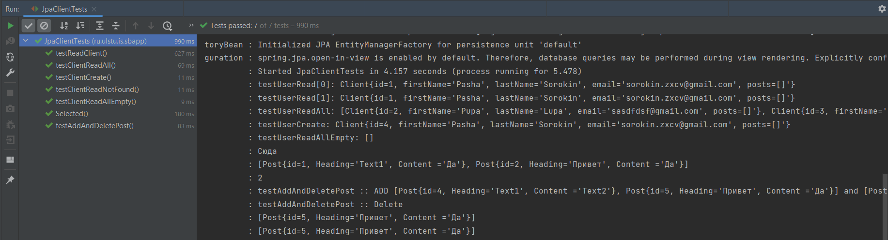
Тесты UserService
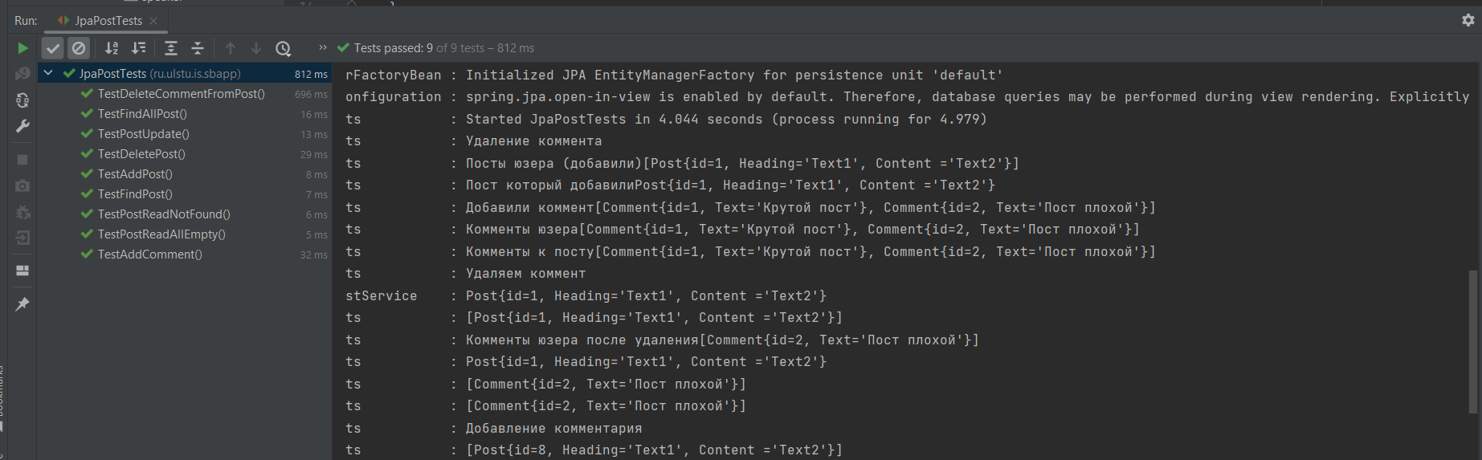
Тесты PostService
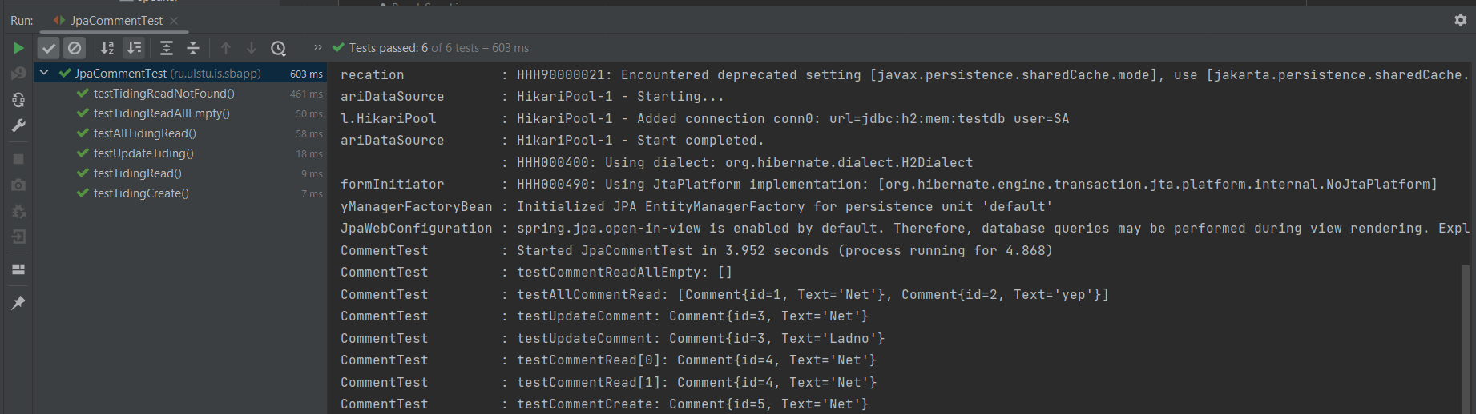
Тесты CommentService

